Adding Billing Information
Add billing information to seamlessly purchase subscriptions and add additional employees without having to re-enter your credit card information each time.
- In your settings menu on the lower left side, select Billings & Subscriptions
- On the Overview tab, select ‘Add your payment method’
- Fill out the required billing information, and Save
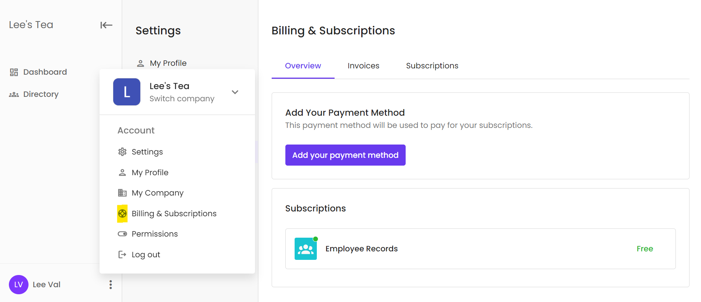

Purchasing a subscription
To purchase a new subscription while logged into the platform, follow these simple steps
- In your settings menu on the lower left side, select Billings & Subscriptions.
- Toggle between Annually and Monthly to see the price difference per employee per month.
- Select ‘Learn More’ to read about the subscription.
- Select ‘Subscribe’ to start the check-out process.
- The price will be automatically calculated based on the billing cycle preference (annually or monthly) and the number of active employees you have in the company.
- Add Billing information if you don’t already have it saved.
- Once all valid information is entered, select ‘Subscribe’.
- You can now enjoy your new subscription!

Notes:
- When new, active employees are added to your company, you will be billed monthly for the prorated amount of the additional employees.
- When employees become inactive or are removed from your company, you will be credited the prorated amount on your next billing cycle.

