# Configuring Schedule

Keep employee schedules organized by managing shifts and employee times. To configure your Schedule, navigate to Time & Attendance 🡪 Configuration 🡪 Scheduling

Here you can manage shift labels and set up the day your work week begins.

Set up shift labels to categorize different shift types and visually identify shifts on the calendar.

# Managing Shift Labels

Set up shift labels to categorize different shift types and visually identify shifts on the calendar. A default shift is automatically created so you can immediately get started. This shift label is not editable.

Create a new shift label by selected ‘Create new label’. Enter a shift label name and select a color. This color will be reflected on the calendar when the label is used.

# Managing Schedule Titles

Schedule titles can be used to create individual schedules for various departments or business functions. A default schedule title is available to use so you can start adding shifts right.

Shifts can be added to individual schedule titles and each schedule must be published individually.

To create a custom schedule title, select the title dropdown on the top left of the calendar – it will display ‘Default Schedule’. When the drop down opens, you will see the option to ‘create a new schedule title’.

Enter a schedule title and optional description.

Once created, the calendar will transition to that schedule.

If given permission to Time & Attendance, employees will be able to see their **published** schedules for all schedule titles.

# Setting Employee Availability

Set employee availability so you can visually see in the schedule when they are able to work. When in the Schedule section, under Team Schedule, you will see the employees that have a shift on the schedule you are viewing.

1. On the right side of the employee name, select the vertical menu icon 🡪 Edit Availability
2. You can set the maximum amount of hours an employee can work each week so that it’s easy to see if their shifts go over that amount.
3. Then you can select the days and input the hours they are available
4. Toggle ‘All Day’ if the employee is available all day
5. Select Save

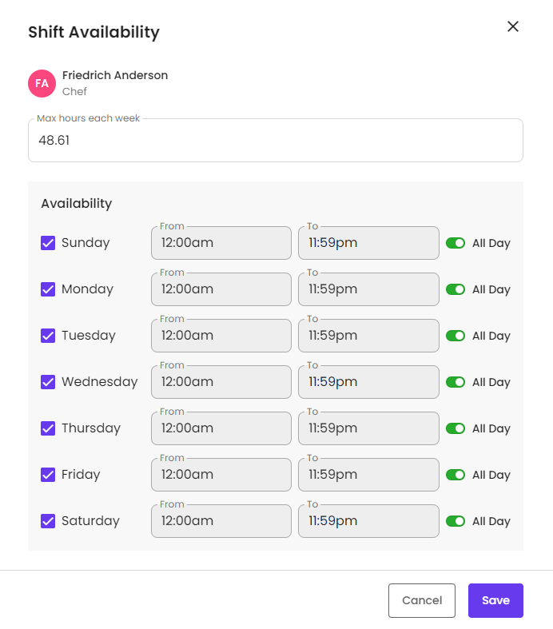

**Note:** If an employee is unavailable on a certain day, this will be reflected in the calendar. However, you are allowed to schedule a shift that day in case there are instances they may be available that week.

# Adding a Shift

Add shifts to start preparing your schedule.

1. Select ‘Add a shift’ button or select a date directly within the calendar
2. The ‘Add Shift’ modal will come up
3. Note: You may update the Schedule Title
4. Select one or more employees
5. Select the shift label
6. Select the date
7. Select the start time, end time and break length
   1. Note: The break length will not be included in total hours scheduled for the employee
8. You may leave an optional comment
9. Select Save

Once saved, you will see the shift on the calendar. It’ll be easy to recognize based on the color of the chosen shift schedule.

Don’t forget to publish if you are done adding shifts! Learn how to publish a schedule here.

# Publishing a Schedule

When you are ready for you employees to see the schedule for a certain week, you can publish that schedule title.

1. To publish a schedule, make sure you are on the right schedule title and week you want to publish.
2. Select the ‘Publish’ button at the bottom of the Schedule page
3. You will see a pop up to confirm you want to publish
   1. This will include a summary of the total shifts, total hours and total shift labels on that week’s schedule.
   2. You will also have the option to notify the employees on the schedule for that week or to not send any notification emails.
4. Select Publish

Once published, if you selected to notify employees, emails will go out prompting employees to log in and view the schedule.

**Note:** You can still edit a schedule after it is published. Just remember to publish again so employees are aware.

# Notifying Employees of Schedule

Notify employees of a schedule for a certain week so they know when they are scheduled to work.

1. You may choose to notify employees when publishing a schedule
2. You also have the option of notifying employees by selecting the menu option (on the left side of the ‘Add a shift’ button’, then selecting ‘Send email notifications’.
3. If you select ‘Send’, emails will go out to all employees on that week’s schedule.