# Setting up Time Off Policies

Time Off Policies allow you to configure how you allow employees to accrue and use time off hours. You can choose your time bank preferences, frequency of accrued time, amount of accrued time, benefit start date, carry-over rules, and more. You can configure multiple policies for different employee types.

# Time banks

Your company will have three time banks available to configure: Vacation, Sick, and PTO. You can configure each bank as needed per time off policy created.

**NOTE:** If your company or a policy does not use a certain time bank, be sure to put ‘0’ for the amount of accrued hours and does not accrue negative hours. The other settings will not impact this bank.

# Creating a new time off policy

1. Navigate to Time Off Policies from the side menu
2. Select to add a new time off policy
3. You will see a pop up to input a name and description for your policy

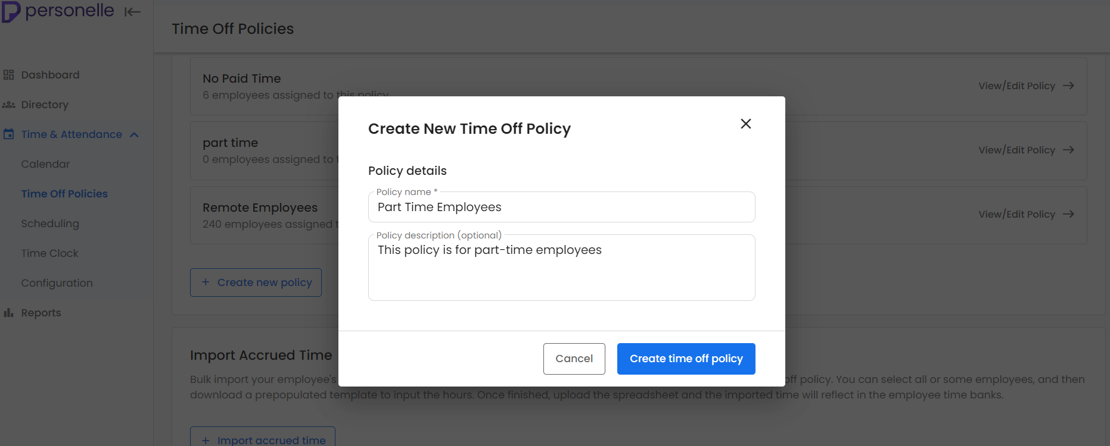

1. Select ‘Create time off policy’ to continue setting up the rest of the details.
2. If you want all new employees to be automatically placed into this time off policy, you make select the ‘mark as default’ option.  
   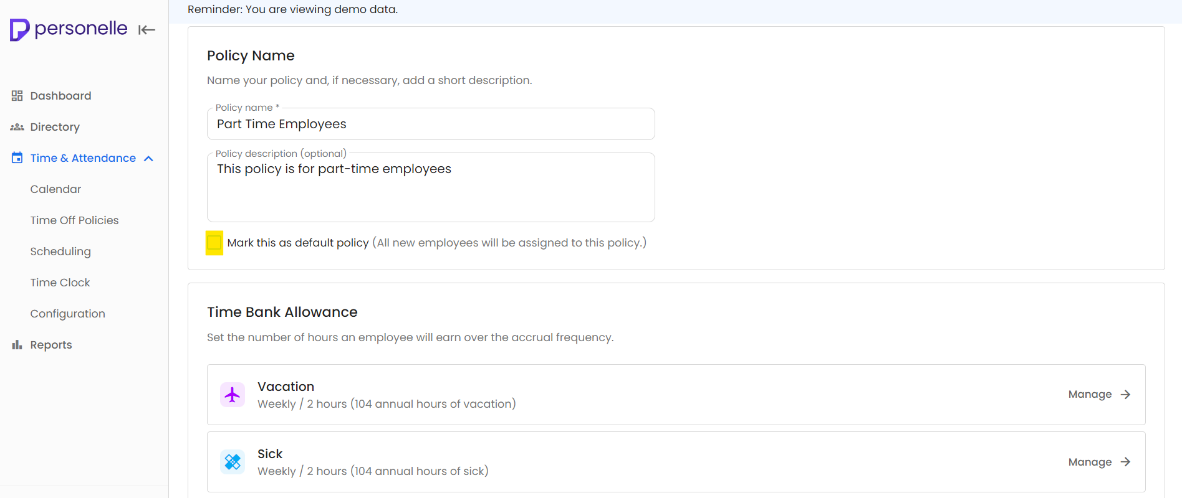
3. In the Time Bank Allowance section, you will see the time banks previously set up in configuration. Select ‘Manage’ on the right side to set up the following:

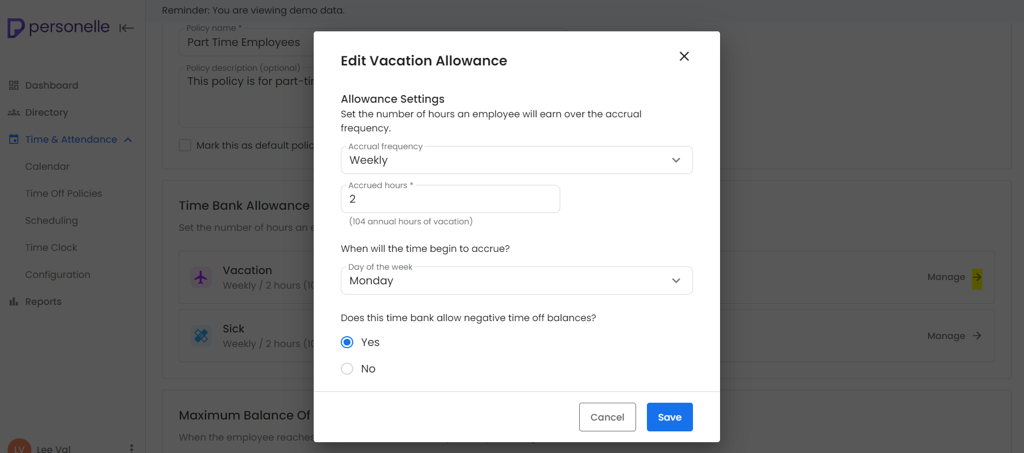

1. **Frequency**: Select how often you want time to accrue. You can choose between weekly, biweekly, semi-monthly, monthly, or yearly.
2. **Hours**: Select how much time you want to accrue at the chosen frequency. You can input whole hours or time up to two decimal places.
   1. Example: Employees can accrue 4.2 hours every 2 weeks.
   2. 4.2 is the amount of hours and 2 weeks (biweekly) is the frequency. This is configured per policy so you can set up a different amount of hours and frequency on a different time off policy.
3. Then select the day of the week you want time to begin to accrue.
4. You can then decide if you want to allow employees to go into a negative balance on the selected time bank.
5. Select the save button to continue.
6. When you are done configuring the Time Bank Allowance, you can scroll down to the Maximum Balance.
   1. This section allows you to determine when employees should stop accruing time, if at all. You have the option to select No Limit or add a custom limit in number of hours.
7. **Benefit Year**: When should employees start accruing hours for the year? Use this option to select when you want your employees to begin accruing the amount of hours. You can start at the beginning of the year (January 1), a custom fiscal year, or at the individual employee’s hire date.
8. **Carry** **over**: Customize how your company allows employees to carry over hours they have not used during the benefit year. You may allow employees to carry over all unused hours, up to a specific amount of hours, or none at all.
9. Additionally, you may allow employees to carry over unused hours up until a specific month.
10. **Paid Holidays**: You may also want to customize the paid holidays on each policy. We set up default holidays for you to choose from but you may also add your own.

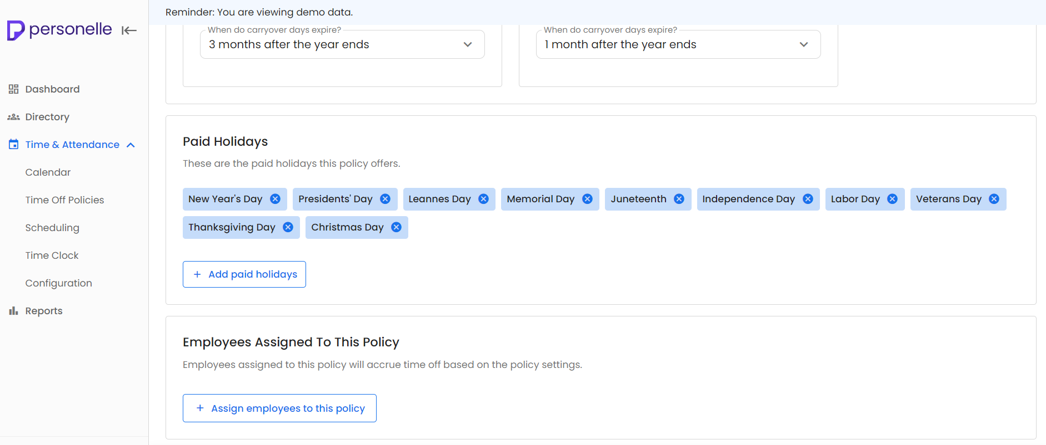

1. Select the ‘x’ to remove a holiday.
2. Select ‘Add paid holidays’ to add more holidays or add a custom holiday.

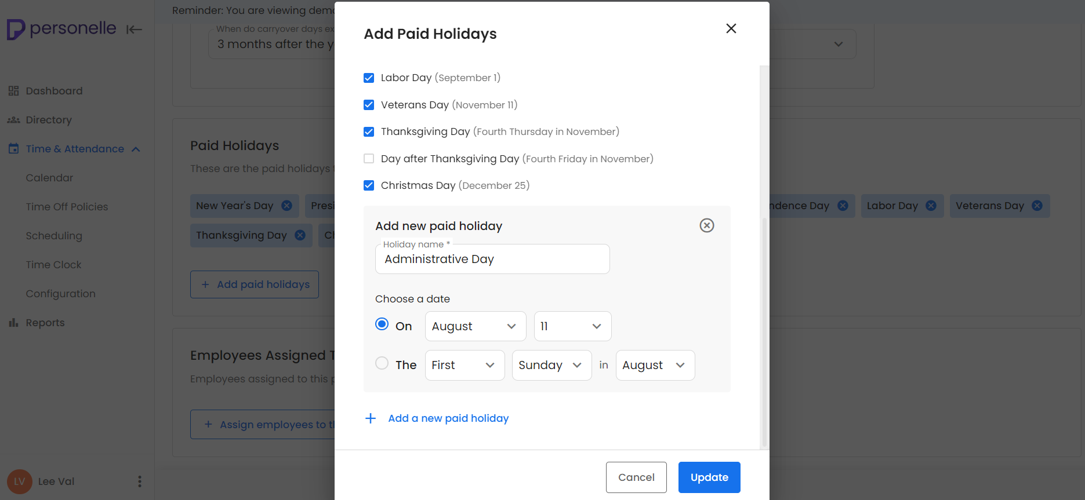

# Adding Employees to a Time Off Policy

The very last section when managing a policy is ‘Employees Assigned to this policy’. This is where you can add or remove employees from the selected policy.

Select ‘Assign employees to this policy’ to get started.

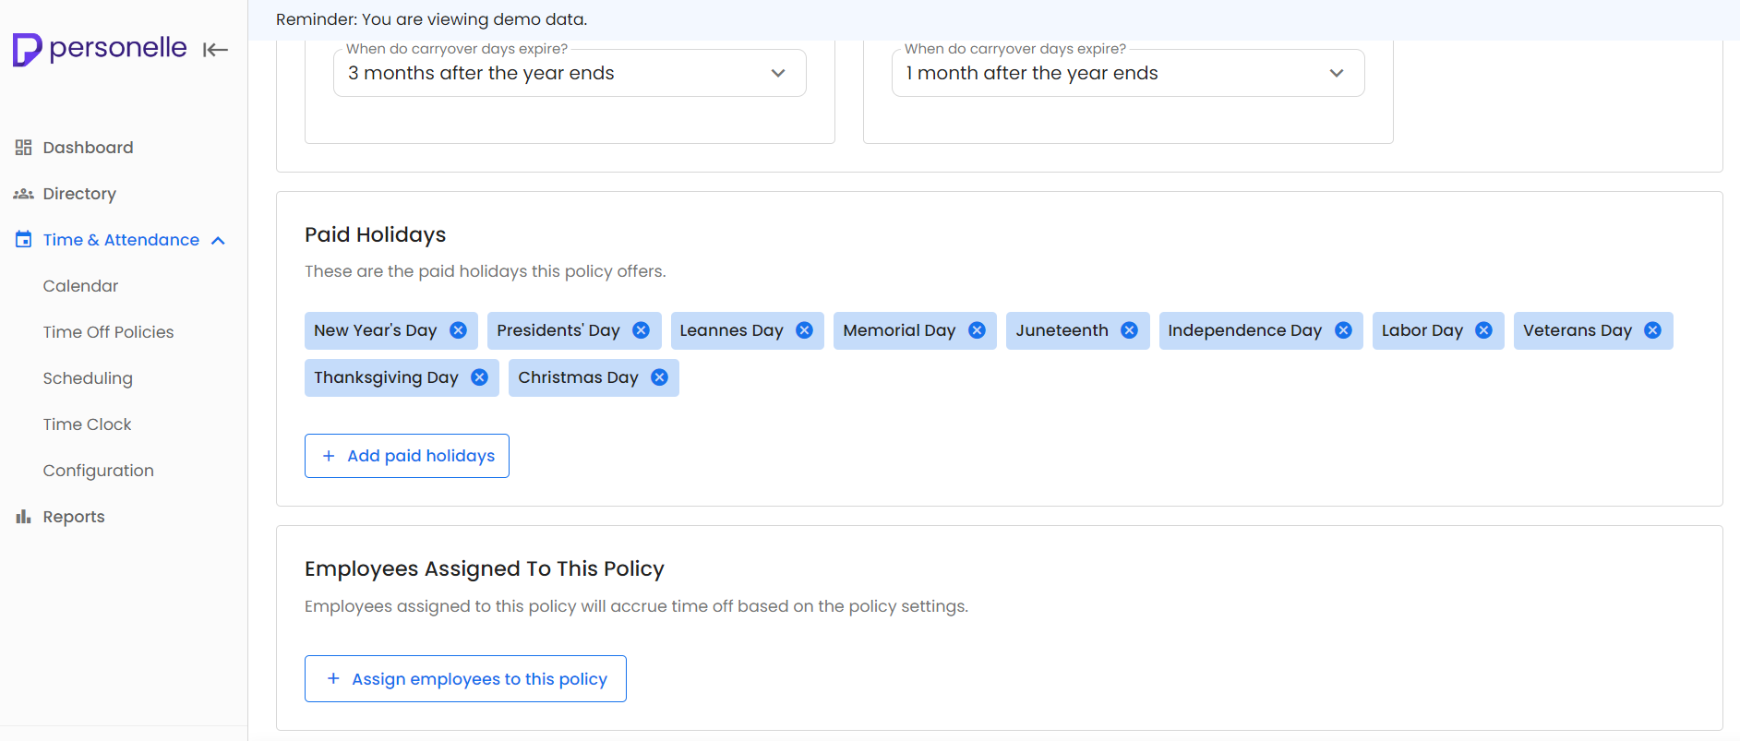

You can go through your list of employees and select them as you scroll. Or you may use the many filter options to quickly find the employees you want to add to the policy.

