# How to get started in Personelle

Use this guide to easily get started in Personelle by adding your employees.

When you create your account and log in for the first time, you will land on the Dashboard page. The Dashboard is a quick summary of important information you may need for the day. We will continue to add valuable widgets to this page.

To start adding employees, select to go to the Directory page.

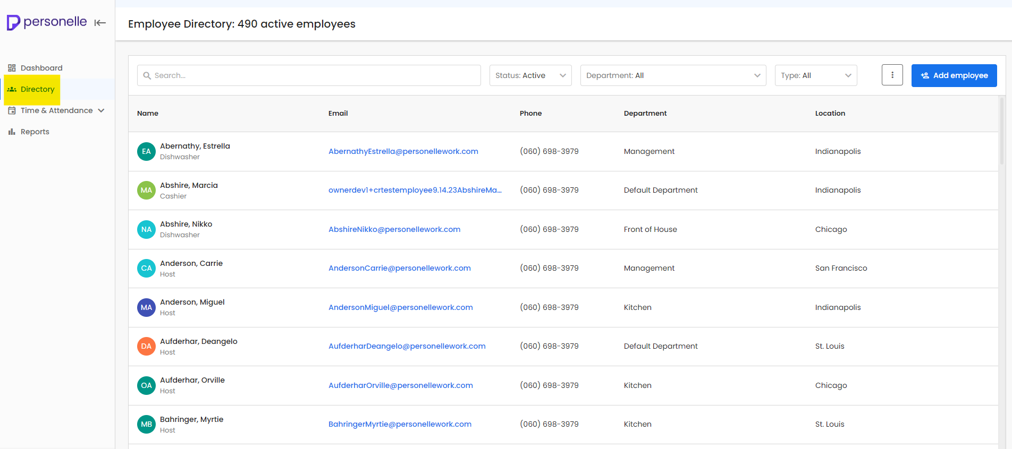

**Adding Employees**

There are two ways to add employees: manually adding an employee or importing employee information in bulk.

# Manually Adding an Employee

To manually add an employee, follow these simple steps:

1. Select ‘Add Employee’ on the right side. A pop up will open.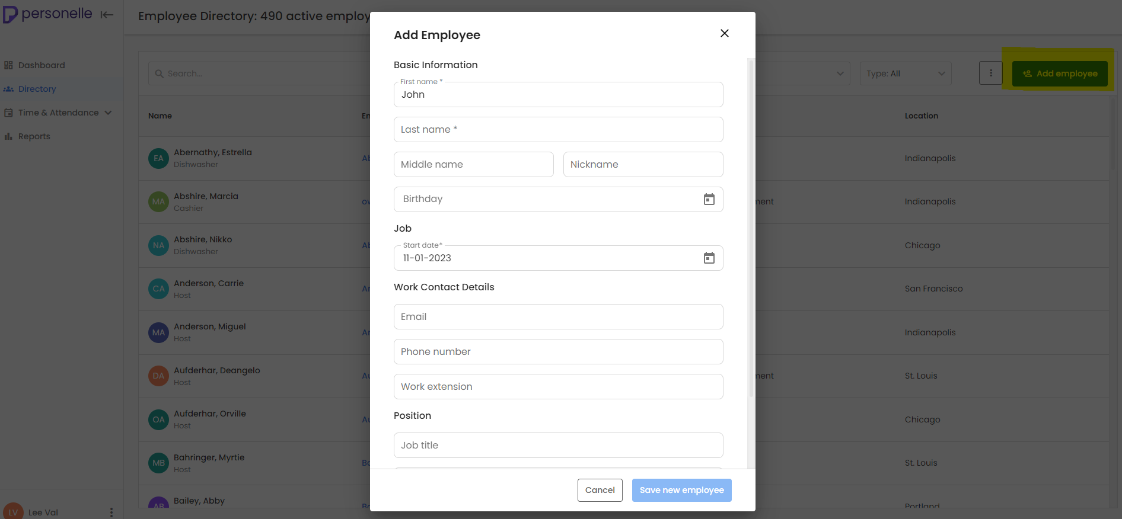
2. Fill out the required information as noted with asterisks* and any other information you wish to add.
3. Select ‘Save new employee’ button on the bottom right side of the modal
4. You will see all saved employees in the directory.
5. Select the employee from the directory to open their employee profile
6. You can edit or add any additional information by navigating through the different tabs on the profile.

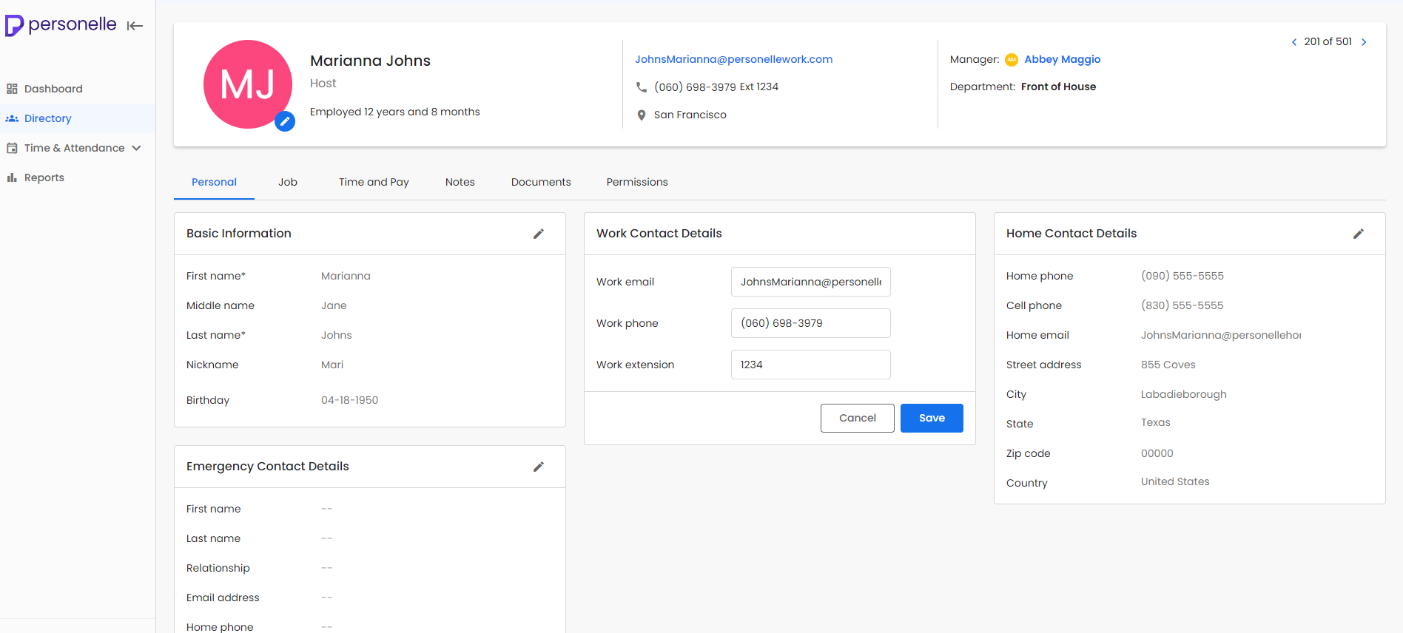

# Importing Employees in Bulk

Importing employees in bulk serves as a convenient option to gather all employee data on a single spreadsheet versus manually adding it one-by-one in the platform. You will be able to add most employee information or just the required information if you prefer.

1. To start the employee import process, select the menu option on the top right next to the “Add employee” button on the Directory page.
2. Select Import Employees.
3. On the next screen, there is an option to download the employee import template. This contains the columns of data in the order needed to successfully import data.
4. Download employee import template.
5. When the template is downloaded to your computer, you can manually fill out the spreadsheet or you can copy and paste from other spreadsheet/exports you may have from other systems. Please note that the columns must maintain the order in the originally downloaded spreadsheet. Additionally, the format of data must be valid in order to successfully import. If data is invalid, we will show you any errors after import. You may fix this inline or by discarding any rows with errors and re-importing.
6. Once the template is filled out, go back to the platform. If your session ended, you can go back to the menu on the Employee Directory and select import employees.
7. Select the option to upload.
8. Select the file you wish to upload.
9. You will see an indication of your file loading.
10. Once loaded, you can review any data that has errors.
11. You may choose to edit the fields with errors.
12. Once done editing, select to save updates.
13. Or you can discard the rows, and upload the rest of the employees that do not have errors
14. Select to upload.
15. You will be navigated to the employee directory page where you will start to see your employees loading in the directory.
16. If you uploaded a lot of employees, it may take some time. You will see a loading indicator on the top of the page. You may continue to use the platform while employees load.
17. You will see all saved employees in the directory.
18. Select the employee from the directory to open their employee profile.
19. You can edit or add any additional information by navigating through the different tabs on the employee profile.



# How to invite employees to self-service

How to invite employees to self service

Self-service allows employees to gain access to the platform so they can access their information and perform tasks as applicable based on their permission level. See permission levels here. Once invited, they will be able to log in. In order to be invited, the employee must have an email address on their profile. This allows an email to be sent to them with the invitation

There are two ways to invite employees to the platform. You can invite an individual employee from their employee profile. Or you may invite employees in bulk.

**How to invite an individual employee to create an account within your company**

1. Navigate to the employee’s profile
2. Select the Permissions tab, which is the last tab on the profile
   1. Ensure the employee has a valid email address on their profile. You will not see this tab if they do not.
3. Select “Invite Employee”
4. The employee will receive an email with a link to create a password. They will then be able to log in and access your company based on the permissions you allow. To access permissions, go to Settings 🡪 Permissions, then select the subscription you want to manage.

**How to bulk invite employees to create an account within your company**

1. On the Directory page, select the menu option on the top right next to the “Add employee” button.
2. Select “Invite Employees”
3. On the next screen, you can select the employees you want to bulk invite.
4. Use the filters to quickly find the employees you want to invite.
5. Once all of the employees you want to invite are selected, select the ‘Send Invitations’ button on the bottom right.
6. The employee will receive an email with a link to create a password. They will then be able to log in and access your company based on the permissions you allow. To access permissions, go to Settings 🡪 Permissions, then select the subscription you want to manage.

# How to set up permissions for employees in Employee Records

How to set up permissions in ER

1. Select Settings 🡪 Permissions
2. Select ‘Manage Permissions’ for Employee Records
3. Employee Records has three different permission levels: Employee, Supervisor, Admin
   1. Admins will be able to perform all functions within the subscriptions for all employees within the company including viewing and editing all employee data. With sensitive HR data, it’s important to give this permission only as absolutely needed!
   2. Supervisors will be able to manage basic information and perform basic functions for only their direct reports. Learn how to assign direct reports here.
   3. Employees will be able to manage their own basic information.
4. On the lower half of this page, you can view the employees within each permission
   1. Tip: Use the search bar to quickly find an employee
5. Select the edit icon to update their permission level
6. Use the ‘Assign Permissions in Bulk’ option to conveniently assign multiple employees to a permission level all at once.

# Employee Records permission levels

1. Employee Records has three different permission levels: Employee, Supervisor, Admin
   1. Admins will be able to perform all functions within the subscriptions for all employees within the company including viewing and editing all employee data. With sensitive HR data, it’s important to give this permission only as absolutely needed!
   2. Supervisors will be able to manage basic information and perform basic functions for only their direct reports. Learn how to assign direct reports here.
   3. Employees will be able to manage their own basic information.